**PED issues troubleshooting**

Table of Contents

1. **Short summary and hot fixes2**
2. **Detailed troubleshooting guide5**

Troubleshooting on ATM user account5

Troubleshooting on local administrator8

Temporary profile8

Ocius issues11

1. **Reinstalling Ocius17**
2. **Configure Ocius20**
3. **Short summary and hot fixes:**

On ATM user (ucxxxp-atm), when vista is running check those points:

**On ATM user:**

1. **After rebooting ATM does ocius start only once on ATM user in background?**
2. **Ocius is starting only once after reboot-**

**Solution:** Proceed with troubleshooting by attempting to pay for a movie.

(Section *Troubleshooting on ATM user account* page 5.)

1. **Ocius is starting two times after reboot-**

**Solution:** Disable Ocius autostarting in “Msconfig” and “startup”

(Section *Ocius will start two times* page 14.)

1. **When attempting to pay for a movie, is ocius logging in background?**
2. **Ocius is logging, but it is still not accepting card payment**

**Solution:** reinstall and configure ocius.

(Section *Reinstalling Ocius* page 17 and *Configure Ocius* page 20)

1. **Ocius does not log in in background:** Proceed to troubleshoot on administrator.

(Section *Troubleshooting on local administrator* page 8.)

**On local administrator:**

**When trying to log in manually to ocius by typing in site login and pin:**

1. **Ocius does log in, however it did not log in on atm user before.**

**Solution:**

-make sure security settings are correct on “comidea” folder

(Section *Configure Ocius* page 26.)

**-**Check for temporary profile and fix it.

(Section *Temporary profile* page 8.)

1. **Ocius won’t log in on administrator account:**

**Solution:** Check if PED is being detected, if not this is a hardware issue.

**If PED is detected:** Uninstall ocius and delete Comidea regedit entry, after that install and configure PED from scratch

(Section *Reinstalling Ocius* page 17 and *Configure Ocius* page 20)

1. **Detailed troubleshooting guide:**

**Troubleshooting on ATM user account:**

There are two things to check when starting troubleshooting PED on ATMs:

1. Is ocius starting only once after reboot:

Reboot the ATM. After rebooting, when vista is running, press “alt +tab”.

This is the way it should look like:

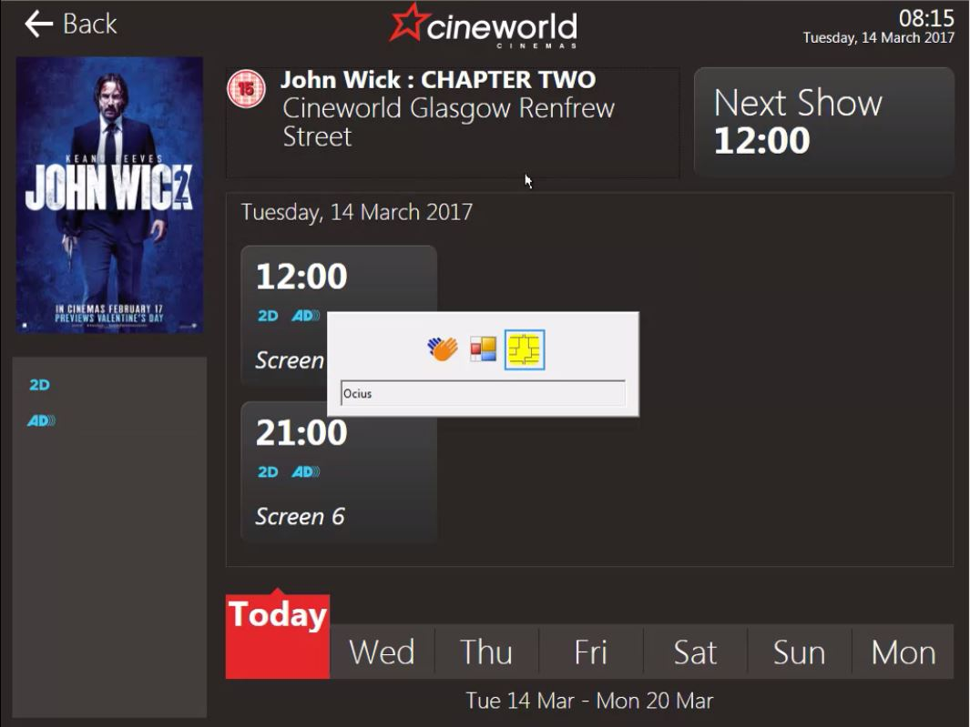

On this stage PED will show “Ocius disconnected”. Pick any movie and proceed to payment.

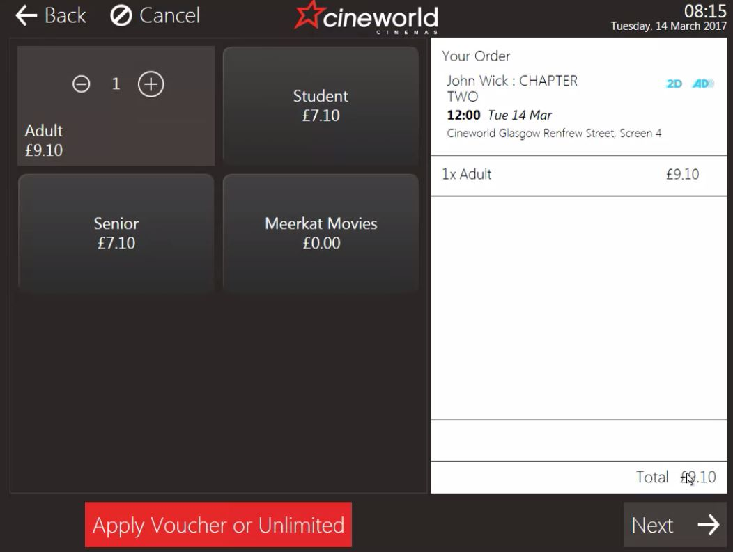 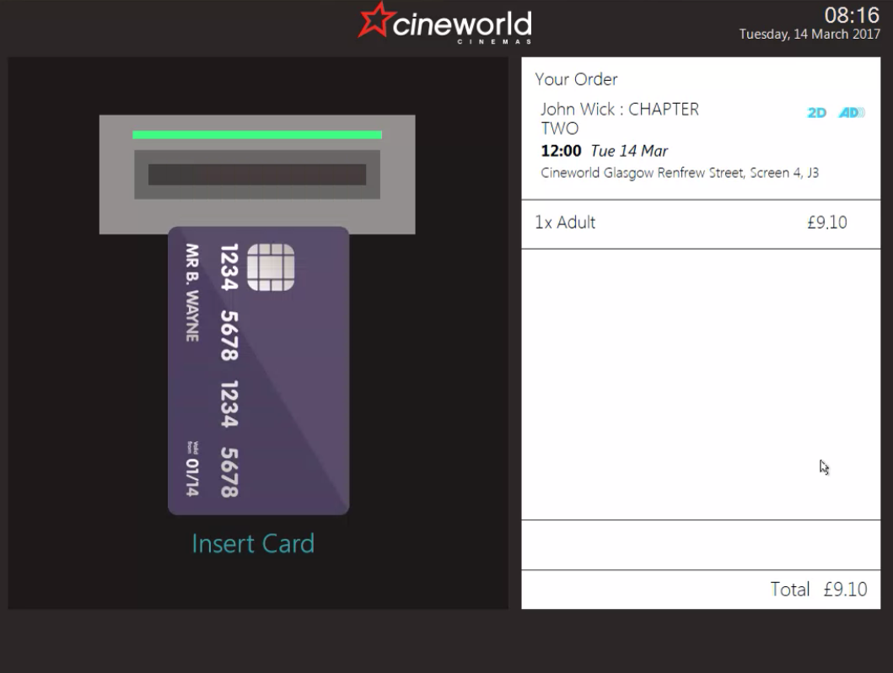

After seeing “Ready” Ocius should log in. Press “alt + tab” to make sure Ocius has disappeared.

.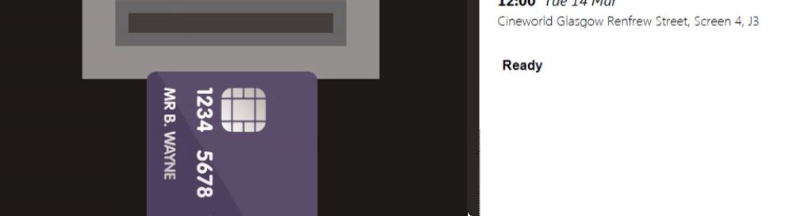 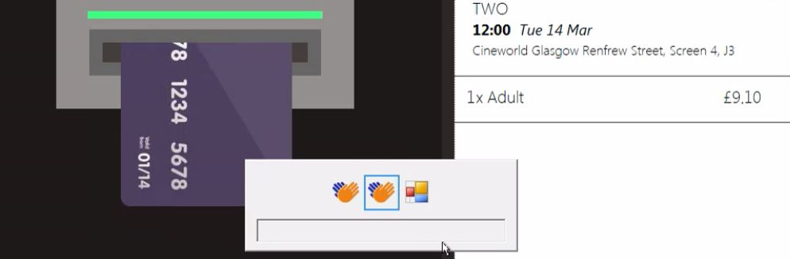

IF After attempting to pay Ocius will not log in.

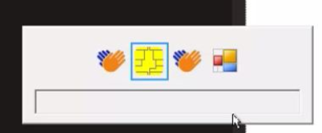

In this case re-log to administrator and proceed with troubleshooting

**Troubleshooting on local administrator:**

**Temporary profile:**

**-Check if there is an issue with temporary profile on ATM.**

When logging in to administrator you may see this popping up in right bottom corner:

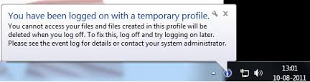

This may be also diagnosed by opening command prompt.

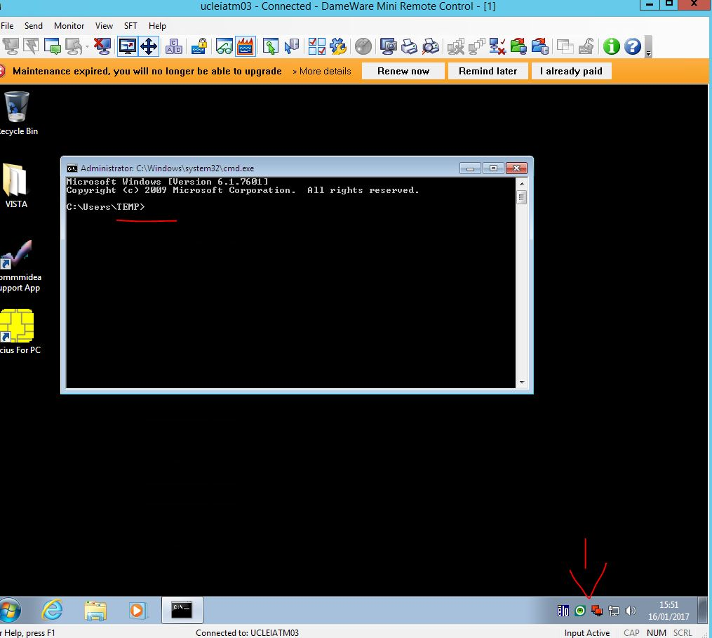

To fix the issue open “regedit.exe” and navigate to HKEY_LOCAL_MACHINE-> SOFTWARE->MICROSOFT->WindowsNT->CurrentVersion->ProfileList

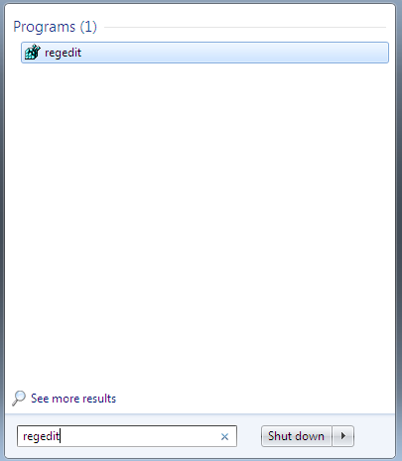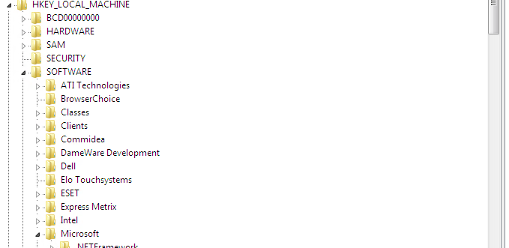

Profiles ending in “.bak” are the proper profiles, they were changed by temporary profiles.

This is how to fix it:

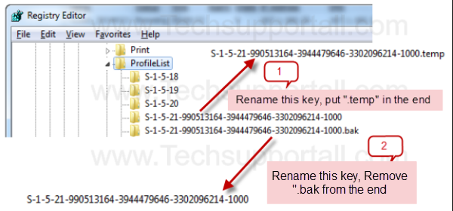

After applying all changes reboot the ATM.

**Ocius issues:**

First go to Oicus and check if there is connection between ATM and PED via ocius.

Open ocius, press F4 and type in config PIN. Go to app settings -> config pinapd and check if PED is being detected on com1 or com2 both for “securaintegrated “ and “secura”.

!Sometimes PED will be detected on “SECURA” please mind you will still have to change PED type to “SECURAINTEGRATED”.

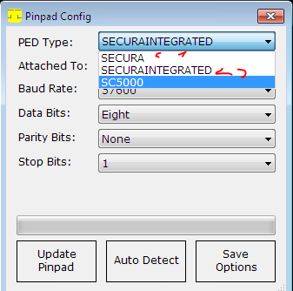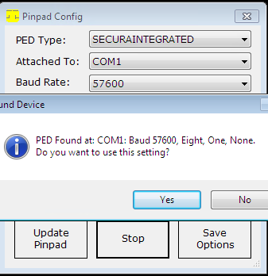

If PED is not being detected neither on “SECURAINTEGRATED” or “SECURA” on both com ports this is a hardware issue

Ask site to check the cables if possible. And replace the PED with vendor.

If PED is detected make sure Ocius configuration is correct.

Once you made sure all this is correct and ocius still won’t log in do the following:

Navigate to ‘’Regedit” and go to HKEY_LOCAL_MACHINE- > SOFTWARE-> delete “Commidea” Key.

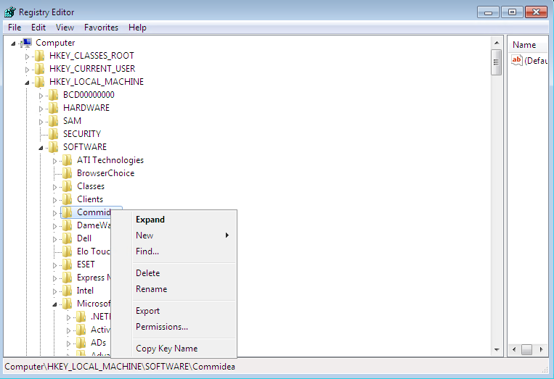

After that open Ocius for PC , try to log in using false credentials (example type in 1 in log in ID and password”. You will see “log in failed” message.

Try to log in again this time using correct credentials (can be found in keepas)

You will see ocius updating”

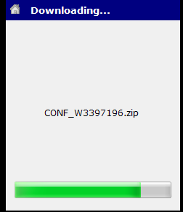

After this check if Ocius is logging in on administrator

**Ocius will start two times, one of them will log in however it still won’t work (accept payment on vista.)**

Re-log to administrator and check:

* Msconfig.exe navigate to startup and check if there is “Ocius for PC” there. If this is the case untick the box and click “apply”

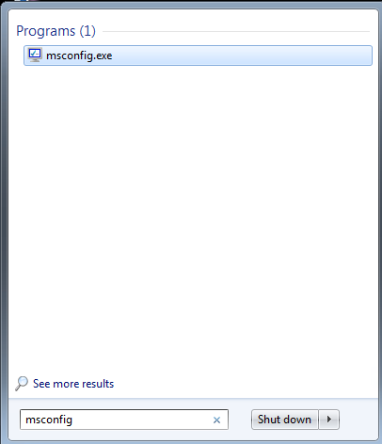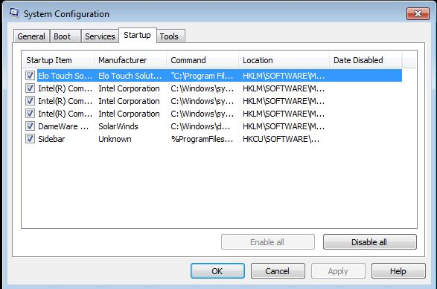

-Press windows logo in the bottom left corner of the screen and click on “All programs”, right click on “startup” and pick “explore”

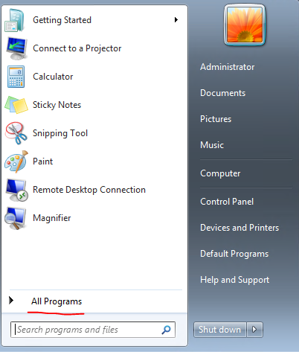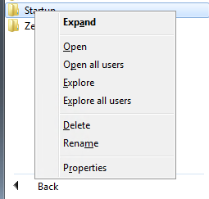

Check if the folder is empty

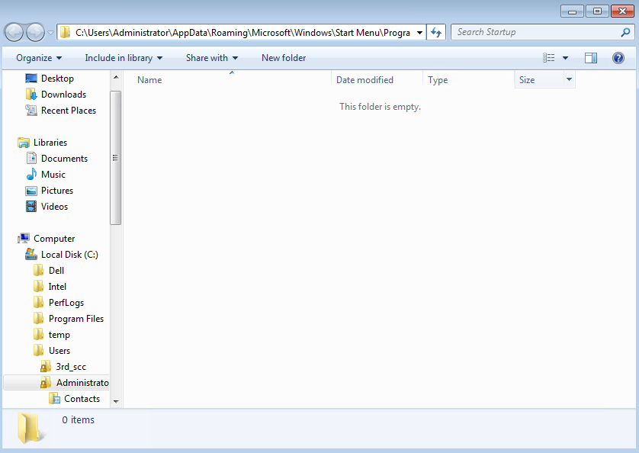

If there is shortcut to ocius there, delete it.

Check also the same path for atm user by changing “administrator” to the name of the user.

Name of the atm user will be always “ucxxxp-atm” where xxx is sites code. For example Glasgow Renfrew Street will be “GRS” therefore atm username will be “ucgrsp-atm”

After changing this press enter, Check if this folder is empty as well

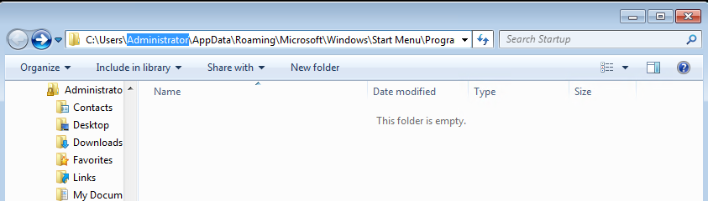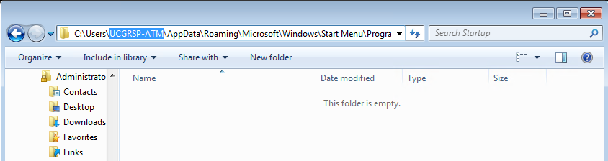

1. **Reinstalling ocius:**

When receiving information about chip and pin not working on the ATM safest bet is to start from reinstalling ocius as this also serves as troubleshooting process.

First re-log to administrator (see part1)

As the previous user is still logged in we need to log him out in order to proceed with reinstallation

Click “CAD” icon. Click “start task manager” and go to users tab, log off ATM user.

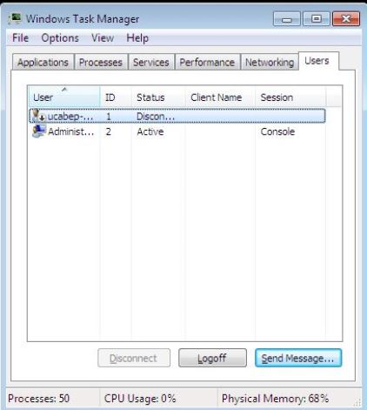

**Find ocius installation file**:

1. Usually it is on ATM in “C:\Windows\dwrcs\Uploads.”
2. If this is not the case you can try to find install file on another ATM using file explorer to enter the same path \\ucxxxatm01\c$\Windows\dwrcs\Uploads where xxx is a site code.

for example: \\ucABEatm01\c$\Windows\dwrcs\Uploads

1. Installation file for ocius can also be found on viscin1 site (\\ucxxxp-viscin1\ where xxx is site id)

**Ocius installation**

**First we need to delete old ocius**

Click on setup. Chose remove.

Go to “C:\Program Files” and make sure that “Commidea” folder has been removed. If not delete it manually

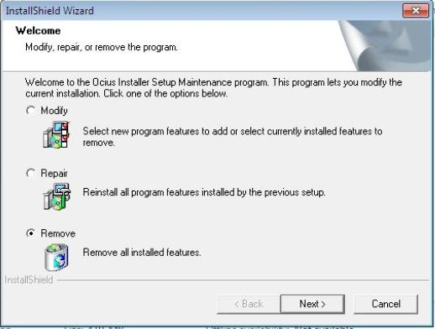

**After that install ocius once more**

Go again to C:\Windows\dwrcs\Uploads and run setup once more.

Click “Next”, Click “Bypass” and “Ok” when warning pops out.

In “User name” and “Company name” type in “Cineworld Cinemas”

Procced with installation by pressing “Next” and press finish

Copy “Ocius” and “TerminalGUID.dat” to “C:\Program Files\Commidea\Ocius For PC”

1. **Configuring ocius:**

Start ocius from desktop. You should see this:

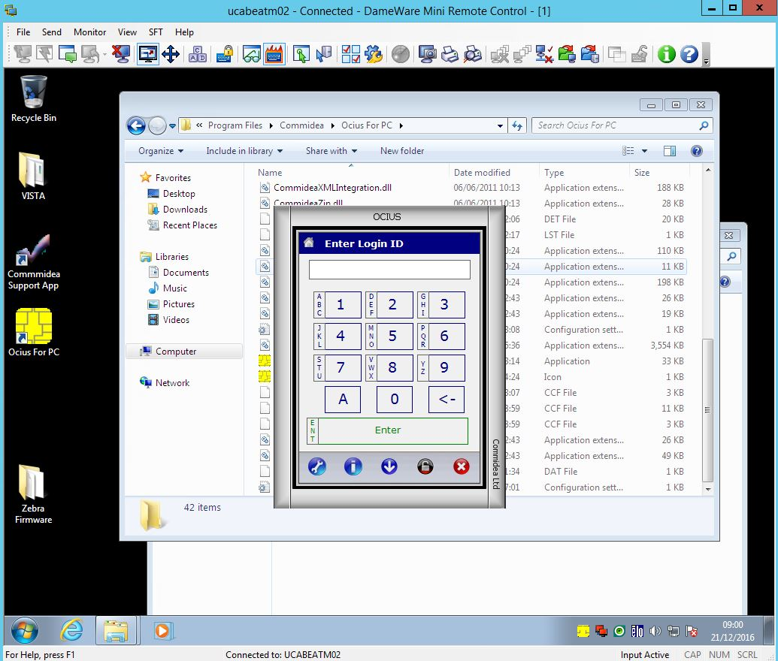

Press “F4”

Configuration pin is “2580”. After that press “enter”

Remember to input all credentials using keyboard and not OCIUS prompt as this information is confidential.

Go to:

“3. app settings” and then to “1. Config Pinpad”

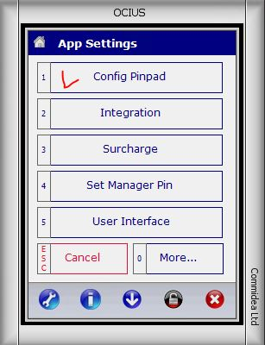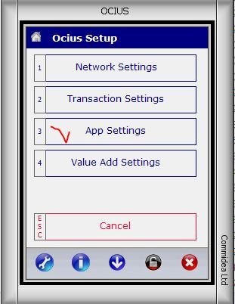

Check if those are correct:

“Ped type” for now should be ‘SECURA”

“Attached to” should stay at “COM1”

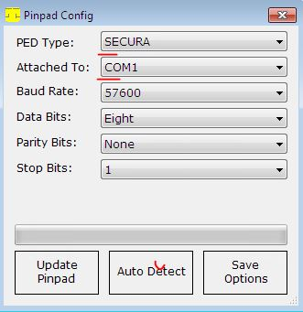

Press auto detect.

Ocius should almost instantly find PED at COM1

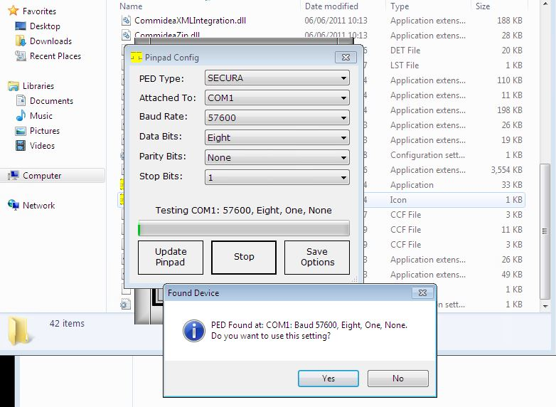

If this is not the case and you can’t see prompt “Found device”, issue is with hardware, site needs to check cable connection. If this does not help PED needs to be replaced

If all is fine click “yes”

After that change “PED type” to “SECURAINTEGRATED” and “save options”

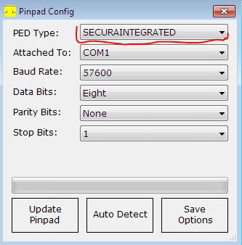

In case when chip and pin is not being detected ask the Manager or person on site to reset the cables that go to chip and pin.

Change “Attached to” on ocius to “COM2” and run auto detect once more.

If that does not help either Chip and pin or port is broken.

In “App settings” go to “5. User Interface” than to “Display Config” then “Form Options” and pick “Screen Only”

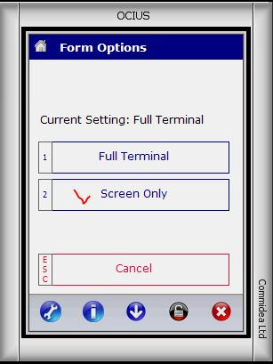

Go back to Display Config -> 2. Operation Mode -> 4. Unattended

Go back to “App settings”. After that go to “0. More…” , “Print Settings, “1. Printer” and chose “4.Windows Printer”.

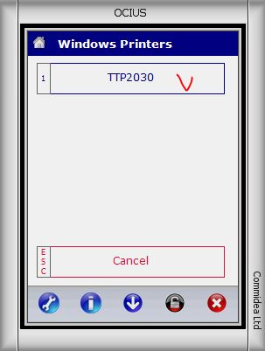

Most ATM’s use either TTP2030 or STAR printer. Pick the one that displays. In this case printer is “TTP2030”

After that go back pressing “esc” multiple times until you see “Start-up”

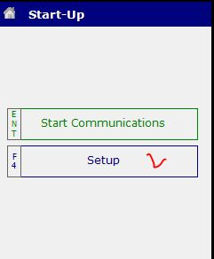

Pick Setup and enter config pin “2580” one more time

Go again to App setting-> More…-> Print Settings-> More… ->6. Extended Receipt Line Line Feeds.

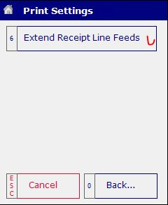Input “4” in “No Of Lines”, press “enter” and go back again to “start up”

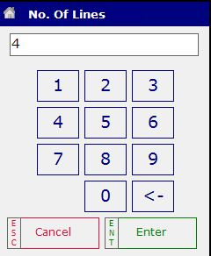

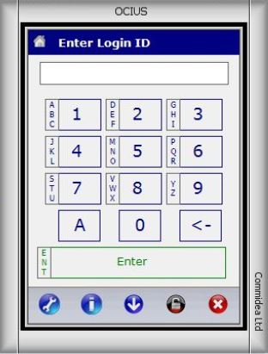Press “Start Communications”

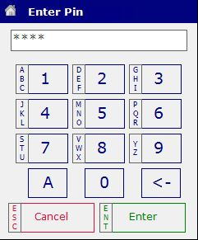

This time simply type in login ID and PIN (they can be found in keepass).

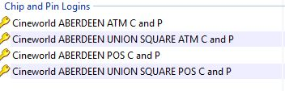

!Remember that:

-Login and PIN are always the same.

-NOTE that those are unique for each site

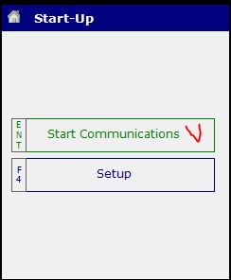Replace account

Manager pin is always 5555

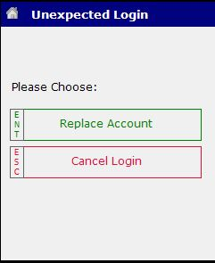After that chip and pin will start to download updates

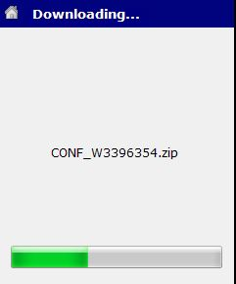

**Security settings**

After that ocius is configured. Last thing to do is making sure that security settings are correct.

Go to “C:\Program Files” and right click on “Commidea” folder picking “Properties”.

Go to “security” tab

Press “edit”

Make sure that “Users” and “Administrators” and “Trustedinstaller” have all permissions ticked

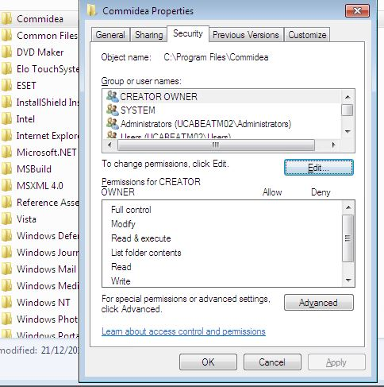Click “Apply”

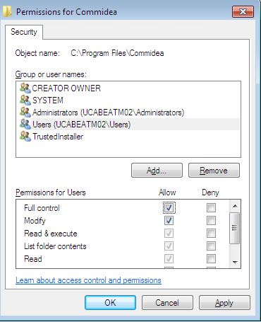

After all is done reboot the ATM